Resultados mediciones 2023 (sin bloque 4)

Maximiliano Zorian

## Supervivencia

Tratados y control

# A tibble: 30 × 4  
# Groups: tratamiento, variedad [10]  
 tratamiento variedad bloque vivas  
 <fct> <fct> <fct> <dbl>  
 1 C CG08 1 52.6  
 2 C CG08 2 44.7  
 3 C CG08 3 36.8  
 4 C CG09 1 71.1  
 5 C CG09 2 55.3  
 6 C CG09 3 63.2  
 7 C Edunni 1 44.7  
 8 C Edunni 2 76.3  
 9 C Edunni 3 76.3  
10 C H105 1 36.8  
# ℹ 20 more rows

**Prueba de hipotesis de significancia para decidir trabajar solo con tratados**

Analysis of Variance Table  
  
Response: vivas  
 Df Sum Sq Mean Sq F value Pr(>F)   
bloque 2 336.6 168.3 0.9266 0.4140   
variedad 4 1457.5 364.4 2.0063 0.1367   
tratamiento 1 12748.2 12748.2 70.1914 1.262e-07 ***  
variedad:tratamiento 4 293.2 73.3 0.4035 0.8036   
Residuals 18 3269.2 181.6   
---  
Signif. codes: 0 '***' 0.001 '**' 0.01 '*' 0.05 '.' 0.1 ' ' 1

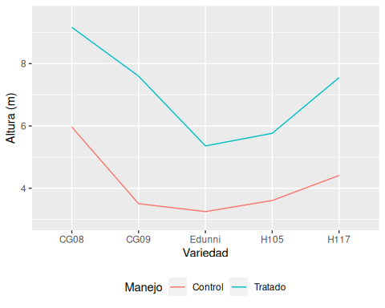

## Sólo Tratados

# A tibble: 15 × 3  
# Groups: variedad [5]  
 variedad bloque vivas  
 <fct> <fct> <dbl>  
 1 CG08 1 26.3   
 2 CG08 2 7.89  
 3 CG08 3 0   
 4 CG09 1 23.7   
 5 CG09 2 7.89  
 6 CG09 3 5.26  
 7 Edunni 1 13.2   
 8 Edunni 2 50   
 9 Edunni 3 10.5   
10 H105 1 5.26  
11 H105 2 21.1   
12 H105 3 2.63  
13 H117 1 10.5   
14 H117 2 5.26  
15 H117 3 2.63

# Altura

# A tibble: 5 × 4  
 variedad media desvio n  
 <fct> <dbl> <dbl> <int>  
1 CG08 9.17 3.63 101  
2 CG09 7.60 2.62 100  
3 Edunni 5.36 1.86 86  
4 H105 5.76 2.09 103  
5 H117 7.55 2.41 107

# A tibble: 1 × 4  
 tratamiento media desvio n  
 <fct> <dbl> <dbl> <int>  
1 T 7.14 2.94 497

# A tibble: 15 × 5  
# Groups: variedad [5]  
 variedad bloque media desvio n  
 <fct> <fct> <dbl> <dbl> <int>  
 1 CG08 1 7.02 2.05 28  
 2 CG08 2 7.55 2.88 35  
 3 CG08 3 12.2 3.06 38  
 4 CG09 1 5.59 2.26 29  
 5 CG09 2 9.05 1.99 35  
 6 CG09 3 7.81 2.45 36  
 7 Edunni 1 4.75 1.27 33  
 8 Edunni 2 5.11 1.78 19  
 9 Edunni 3 6.09 2.17 34  
10 H105 1 6.23 1.04 36  
11 H105 2 4.20 1.87 30  
12 H105 3 6.58 2.35 37  
13 H117 1 5.66 1.44 34  
14 H117 2 8.67 1.86 36  
15 H117 3 8.20 2.62 37

Incluye los tratados… se descarta el analisis

# Modelo

Sin el bloque 4 y sin el control de manejo

numDF denDF F-value p-value  
(Intercept) 1 8 107.27034 <.0001  
variedad 4 8 2.87864 0.0949

Analysis of Variance Table  
  
Response: media  
 Df Sum Sq Mean Sq F value Pr(>F)   
bloque 2 13.637 6.8183 2.9590 0.10916   
variedad 4 26.533 6.6332 2.8786 0.09491 .  
Residuals 8 18.434 2.3043   
---  
Signif. codes: 0 '***' 0.001 '**' 0.01 '*' 0.05 '.' 0.1 ' ' 1

Shapiro-Wilk normality test  
  
data: resid(mALT_nl)  
W = 0.91786, p-value = 0.1787

Levene's Test for Homogeneity of Variance (center = median)  
 Df F value Pr(>F)  
group 4 0.4185 0.7919  
 10

# Graficos

## Tratado y sin B4

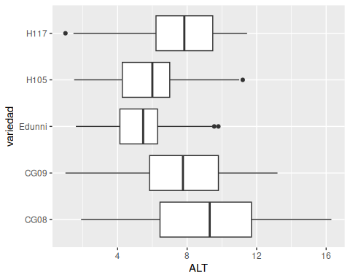

LSD

contrast estimate SE df t.ratio p.value  
 CG08 - CG09 1.4545 1.24 8 1.174 0.2743  
 CG08 - Edunni 3.6201 1.24 8 2.921 0.0193  
 CG08 - H105 3.2657 1.24 8 2.635 0.0300  
 CG08 - H117 1.4249 1.24 8 1.150 0.2835  
 CG09 - Edunni 2.1657 1.24 8 1.747 0.1187  
 CG09 - H105 1.8112 1.24 8 1.461 0.1821  
 CG09 - H117 -0.0296 1.24 8 -0.024 0.9815  
 Edunni - H105 -0.3544 1.24 8 -0.286 0.7822  
 Edunni - H117 -2.1953 1.24 8 -1.771 0.1145  
 H105 - H117 -1.8408 1.24 8 -1.485 0.1758  
  
Degrees-of-freedom method: containment

variedad emmean SE df lower.CL upper.CL .group  
 CG08 8.94 1.03 2 4.487 13.38 A   
 H117 7.51 1.03 2 3.062 11.96 AB   
 CG09 7.48 1.03 2 3.033 11.93 AB   
 H105 5.67 1.03 2 1.222 10.12 B   
 Edunni 5.32 1.03 2 0.867 9.76 B   
  
Degrees-of-freedom method: containment   
Confidence level used: 0.95   
significance level used: alpha = 0.1   
NOTE: If two or more means share the same grouping symbol,  
 then we cannot show them to be different.  
 But we also did not show them to be the same.

Dunnet

contrast estimate SE df t.ratio p.value  
 CG08 - Edunni 3.620 1.24 8 2.921 0.0608  
 CG09 - Edunni 2.166 1.24 8 1.747 0.3180  
 H105 - Edunni 0.354 1.24 8 0.286 0.9814  
 H117 - Edunni 2.195 1.24 8 1.771 0.3085  
  
Degrees-of-freedom method: containment   
P value adjustment: dunnettx method for 4 tests

Dunnett's test for comparing several treatments with a control :   
 95% family-wise confidence level  
  
$Edunni  
 diff lwr.ci upr.ci pval   
CG08-Edunni 3.6201480 -0.6108746 7.851171 0.0978 .   
CG09-Edunni 2.1656761 -2.0653464 6.396699 0.4246   
H105-Edunni 0.3544309 -3.8765917 4.585453 0.9972   
H117-Edunni 2.1952601 -2.0357625 6.426283 0.4137   
  
---  
Signif. codes: 0 '***' 0.001 '**' 0.01 '*' 0.05 '.' 0.1 ' ' 1

### Analisis de contrastes

Matriz de contraste, a partir de los tratados (con )bajo manejo: subsolado y fertilización) se compara:

1. El mejor clon (CG08) vs de semilla (Edunni)
2. Promedio de respuesta de clones vs de semilla
3. Clones HH vs GC

contrast estimate SE df t.ratio p.value  
 C1 -1.454 1.24 8 -1.174 0.2743  
 C2 -2.441 0.98 8 -2.491 0.0374  
 C3 -0.384 1.75 8 -0.219 0.8321  
  
Degrees-of-freedom method: containment

variedad emmean SE df lower.CL upper.CL .group  
 Edunni 5.32 1.03 2 0.867 9.76 a   
 H105 5.67 1.03 2 1.222 10.12 a   
 CG09 7.48 1.03 2 3.033 11.93 ab   
 H117 7.51 1.03 2 3.062 11.96 ab   
 CG08 8.94 1.03 2 4.487 13.38 b   
  
Degrees-of-freedom method: containment   
Confidence level used: 0.95   
significance level used: alpha = 0.1   
NOTE: If two or more means share the same grouping symbol,  
 then we cannot show them to be different.  
 But we also did not show them to be the same.

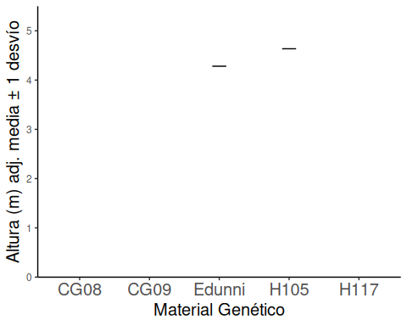

# DAP

# Modelo

* Sin bloque 4 y solo tratados

bloque variedad   
 5 3

numDF denDF F-value p-value  
(Intercept) 1 8 1.469127 0.2601  
variedad 4 8 1.031252 0.4474

Analysis of Variance Table  
  
Response: media  
 Df Sum Sq Mean Sq F value Pr(>F)  
bloque 2 23133 11566.7 2.1373 0.1804  
variedad 4 22324 5581.1 1.0313 0.4474  
Residuals 8 43296 5412.0